**Access to NUS HPC Clusters**

1. Apply NUS nVPN and VPN login with Pulse Secure

<https://nusit.nus.edu.sg/services/wifi_internet/nvpn/>

1. Apply for NUS HPC account

<https://nusit.nus.edu.sg/services/hpc/getting-started/register-for-hpc/>

1. Download any SSH app. ( e.g. MobaXterm Home edition )

<https://mobaxterm.mobatek.net/download-home-edition.html>

1. Start a new SSH session to one of the login nodes with your id eXXXXXXX. ( Replace XXXXXX with your own student id )

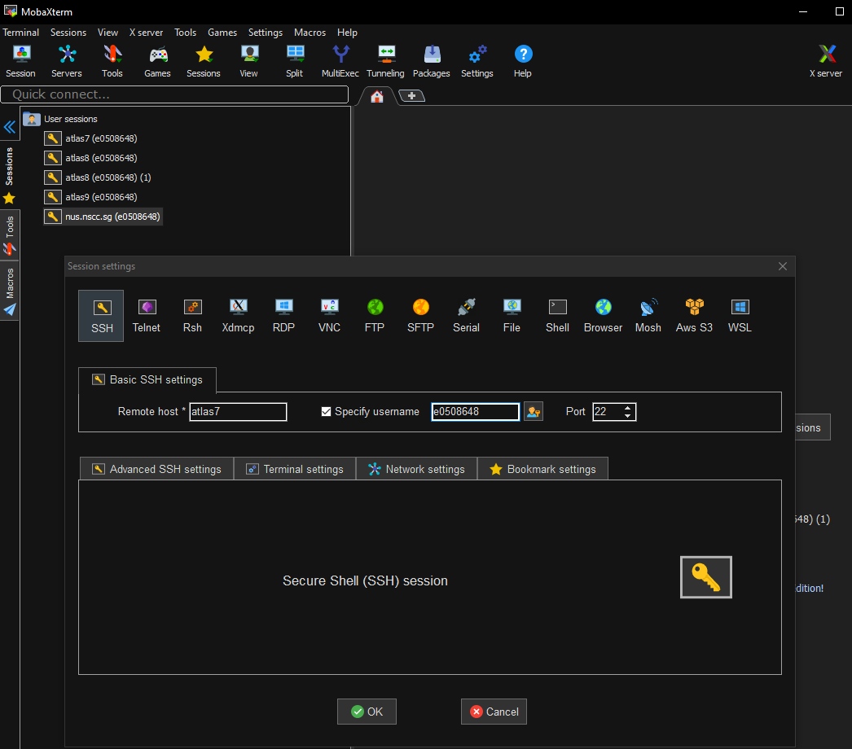

1. In your home directory,

To use conda, run the following commands **once** in the login node:

echo ". /app1/bioinfo/miniconda/3.6/etc/profile.d/conda.sh" >> ~/.bashrc

mkdir ~/conda_envs

echo “export CONDA_ENVS_PATH=~/conda_envs/” >> ~/.bashrc

**NOTE: If you encounter mkdir error, use the MobaXterm to create the folder, I have no idea but only this method works for me**

1. Create a new env with the following commands.

bash

. ~/.bashrc

module load miniconda

conda create -n conda_env_name python=3.7

conda activate conda_env_name

1. Go into the working directory. ( cd /hpctmp/eXXXXXXXX )
2. Drag and drop your .py and any other associated files into the working directory.
3. Drag this .pbs file in.

* Content of parameters below.
* Only change the highlighted in GREEN if necessary
* !! Type dos2unix hello.pbs to convert to unix format if this is transferred from a windows PC. !!



****NOTE: Green is user configurable, Black is fixed ****

#!/bin/bash

#PBS -P Project_Name_of_Job

#PBS -j oe

#PBS -N Job_Name_1

#PBS -q parallel24

#PBS -l select=1:ncpus=24:mem=48gb

#PBS -l walltime=00:24:00

cd $PBS_O_WORKDIR;

np=$(cat ${PBS_NODEFILE} | wc -l);

source /etc/profile.d/rec_modules.sh

module load miniconda

bash

. ~/.bashrc

conda activate conda_env_name

python my_python_script.py

1. Type qsub hello.pbs to submit the job ( Limited to 4 queue jobs at a time )
2. A Job ID output status file will be generated if the job is completed.

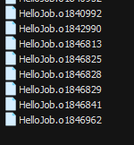

1. Type qstat -xfn to see all your scheduled jobs

**Running Jupyter nb on NUS HPC Clusters**

1. Login to atlas9 (Only atlas9 supports jupyter but no internet access on the node )
2. Set Jupyter passwork ( ONLY ONCE ! )

bash

module load singularity

singularity exec /app1/common/singularity-img/3.0.0/tensorflow_1.12_nvcr_19.01-py3.simgjupyter notebook --generate-config

singularity exec /app1/common/singularity-img/3.0.0/tensorflow_1.12_nvcr_19.01-py3.simgjupyter notebook password

1. Launch Interactive Job from Atlas9

qsub -I -l select=1:mem=10GB:ncpus=5:ngpus=1 -q volta_login -l walltime=0:60:00

1. In Volta1 mode, launch Jupyer notebook

singularity exec /app1/common/singularity-img/3.0.0/tensorflow_1.12_nvcr_19.01-py3.simgjupyter notebook --no-browser --port=8889 --ip=0.0.0.0

1. Open a new Mobaterm tab and run the following

ssh -L 8888:volta01:8889 nusnet_id@atlas9

1. Open browser and browser to <http://localhost:8888>